|  |  |  |
| --- | --- | --- |
| cid:image001.png@01D65A8B.C226B940 | *Achieving Excellence Together* | |
| **Y7 KNOWLEDGE**  **ORGANISER** | | |
| Name: __________________ | | Tutor: __________________ |
|  | | |
| For each subject, this book contains the knowledge that you should learn by the end of…  **Summer 2024-25** | | |

|  |  |
| --- | --- |
| cid:image001.png@01D65A8B.C226B940 | **TIMETABLE** |

Glue your timetable onto this page.

|  |  |  |  |  |  |
| --- | --- | --- | --- | --- | --- |
| A | MON | TUES | WEDS | THURS | FRI |
| 1 |  |  |  |  |  |
| 2 |  |  |  |  |  |
| 3 |  |  |  |  |  |
| 4 |  |  |  |  |  |
| 5 |  |  |  |  |  |

|  |  |  |  |  |  |
| --- | --- | --- | --- | --- | --- |
| B | MON | TUES | WEDS | THURS | FRI |
| 1 |  |  |  |  |  |
| 2 |  |  |  |  |  |
| 3 |  |  |  |  |  |
| 4 |  |  |  |  |  |
| 5 |  |  |  |  |  |

|  |  |
| --- | --- |
| cid:image001.png@01D65A8B.C226B940 | **INTRODUCTION** |

At The Purbeck School, we know completing your home learning is essential to long term academic success.

It allows you to extend your learning and to reinforce what has been learnt in class.

Daily home learning will be in three 20-minute parts:

1. **English: Sparx Reader**
2. **Maths: Sparx Maths**
3. Knowledge organiser **self-quizzing**

|  |  |  |
| --- | --- | --- |
| **ENGLISH:** [**www.sparxreader.com**](http://www.sparxreader.com) | Login: | Password: |

Sparx Reader gives all students access to a rich range of books, with quizzes throughout to support engaged reading.

* Each week, tasks are set Monday to Monday.
* In total, reading and quizzes should take around one hour.
* You must complete 100% in each task.
* Gold Readers can add any book and earn points by keeping reading logs.

|  |  |  |
| --- | --- | --- |
| **MATHS:** [**www.sparxmaths.com**](http://www.sparxmaths.com) | Login: | Password: |

*Sparx-Maths* provides practice on what you’ve learnt in class and consolidation what you’ve learnt through the year.

* Each week, tasks are set Monday to Monday.
* In total, tasks should take around one hour.
* You should show your workings in your orange homework book.
* You must complete 100% in each task.

**SELF-QUIZZING**

Your teachers will quiz you regularly on what you are expected to learn.

* On the subject page in this book, organise yourself by noting:
  + The date of your knowledge quiz.
  + What knowledge you need to self-quiz and learn.
* Pick one of our Independent Study Strategies (see next page) and spend at least 20mins revising.
* Bring evidence of your self-quizzing to the lesson.
* On the day of your knowledge quiz, be prepared and attempt every question.

**SUPPORT**

If you need help with any aspect of your home learning then…

* Please go and see your subject teacher.
* Extra help is also available at Study Plus, our after-school home learning club, every Tuesday – Thursday 3.10-4.10pm in room E14.

|  |  |
| --- | --- |
| cid:image001.png@01D65A8B.C226B940 | **INDEPENDENT STUDY STRATEGIES** |

Independent study involves undertaking activities that will help you to improve in that area.

There are many effective ways you can study independently – here are a few strategies

|  |  |
| --- | --- |
|  | **Self-quizzing – Look, Cover, Write, Check**   * LOOK: Read the question and the answer. * COVER: Cover up the answer column. * WRITE: Write the answer from your memory. * CHECK: Finally, mark your work. Correct any mistakes. |

|  |  |
| --- | --- |
| **Mind Maps**   * Make notes around a key concept or subject. * Draw lines to link definitions, key ideas and related parts. * You may find it helpful to use different colours for different ideas. |  |

|  |  |
| --- | --- |
|  | **Flash Cards**   * Write key points down on flash cards and carry them around with you – look at them as often as you can! * Use them as a quiz – write a key word on one side and the definition on the other, then test yourself. |

|  |  |
| --- | --- |
| **Posters**   * Make your own colourful posters! You can pick any subject as your theme. * Draw diagrams or pictures to go with your text. * Display them in a visible place at home. |  |

|  |  |
| --- | --- |
|  | **Practice Example Questions**   * For many subjects a good way to revise is to work through some example questions. * You can practice these questions over and over to develop your understanding. * If there are parts of questions that you find hard or think you haven’t understood, you can check your notes, search online, or seek advice from your teacher. |

|  |  |  |
| --- | --- | --- |
| **Websites**  These websites provide opportunities for students to learn, practise and get feedback:   * Seneca Learning: [www.senecalearning.com](http://www.senecalearning.com) * BBC Bitesize: [www.bbc.com/bitesize](http://www.bbc.com/bitesize) * Sparx-Maths: [www.sparxmaths.com](http://www.sparxmaths.com) * Free Science Lessons: [www.freesciencelessons.co.uk](http://www.freesciencelessons.co.uk) | | C:\Users\cmorris\AppData\Local\Microsoft\Windows\INetCache\Content.MSO\B091586D.tmp |
| cid:image001.png@01D65A8B.C226B940 | | **KNOWLEDGE ORGANISER SELF-QUIZZING** | | |

This table will help you organise your knowledge organiser self-quizzing.

|  |  |  |  |  |  |
| --- | --- | --- | --- | --- | --- |
| **7X** | **MON** | **TUES** | **WEDS** | **THURS** | **FRI** |
| **A** | DESIGN  SPANISH | SCIENCE (x2)  ART2 | SCIENCE2  RE1+3 | GEOGRAPHY  HISTORY | ENGLISH  MATHS |
| **B** | FRENCH | DRAMA3  RE2 | DRAMA1+2 | ART1+3 | ENGLISH  MATHS |

|  |  |  |  |  |  |
| --- | --- | --- | --- | --- | --- |
| **7Y** | **MON** | **TUES** | **WEDS** | **THURS** | **FRI** |
| **A** | ENGLISHHON  SCIENCE | ENGLISHALR+ATT  DESIGN | SPANISH | MATHS  GEOGRAPHY1+2  RE3 | RE1+2 |
| **B** | ENGLISHATT+HON  FRENCH  ART2 | ENGLISHALR  ART1+3  DRAMA3 | DRAMA1+2  SCIENCE3  HISTORY1 | SCIENCE1+2  HISTORY2+3 | MATHS |

* Class numbers noted in subscript

This knowledge organiser example gives an idea on how you can note the date of your quiz and a self-assessment (RAG) of your knowledge…

|  |  |
| --- | --- |
| cid:image001.png@01D65A8B.C226B940 | **KNOWLEDGE ORGANISER – THE PURBECK SCHOOL** |

|  |  |  |  |  |
| --- | --- | --- | --- | --- |
|  | What is The Purbeck School vision statement? | Achieving Excellence Together | | 1/9/24 |
|  | What are our three core values? | * Kindness * Aspiration * Perseverance | | 1/9/24 |
|  | Who is the Headteacher? | Mr Darley | | 1/9/24 |
|  | Name the four Houses. | * Kestrel * Kingfisher | * Skylark * Swift | 1/9/24 |
|  | What time should all students be in school for every day? | 8.40am | | 1/9/24 |

|  |  |  |  |
| --- | --- | --- | --- |
|  | Where can students buy food at lunchtime? | * Y7: cafe * Y8/9: canteen | 7/9/24 |
|  | Based in the Aim High block, where can students go if they are worried, concerned or having difficulties? | The Nest | 7/9/24 |
|  | As part of home learning, state the three 20min activities that all students complete each evening. | * Reading Plus * Sparx Maths * Self-quizzing | 7/9/24 |
|  | Where can you go to help and support with home learning? | * Your subject teacher * Home learning club | 7/9/24 |
|  | State three extra-curricular activities that a student can get involved in. | * Choir * Sports clubs * STEM | 7/9/24 |

|  |  |
| --- | --- |
| cid:image001.png@01D65A8B.C226B940 | **Y7 ART KNOWLEDGE ORGANISER – THE FORMAL ELEMENTS** |

**LONG TERM PLAN**

|  |  |  |  |  |
| --- | --- | --- | --- | --- |
| **AUTUMN** | **⭢** | **SPRING** | **⭢** | **SUMMER** |
| Formal Elements / Nature | Night Life of Tree and Collagraph | Science and Nature |

|  |  |  |  |
| --- | --- | --- | --- |
|  | When lines, shapes, forms or colours are repeated, this is known as a… | Pattern |  |
|  | What term describes the part that is repeated? | Motif |  |
|  | 1. Draw and label a regular pattern. 2. Draw and label an irregular pattern. |  |  |
|  | What is a pattern of shapes that fit together perfectly, with no gaps? | Tessellation |  |
|  | State the three tessellation techniques. | * Translation * Rotation * Reflection |  |

|  |  |  |  |
| --- | --- | --- | --- |
|  | What term describes circles that are on top of each other, changing in size as you draw another but always having the same centre axis? | Concentric circles |  |
|  | List the 3 primary colours. | * Red * Yellow * Blue |  |
|  | List the 3 secondary colours. | * Orange * Green * Purple |  |
|  | What term describes colours that are next to each other on the colour wheel, that go nicely together? | Harmonious colours |  |
|  | What term describes colours that are opposite each other on the colour wheel and clash to create energy and discord? | Complementary colours |  |

|  |  |  |  |
| --- | --- | --- | --- |
|  | What is a pure hue? | A colour from the colour wheel. |  |
|  | What do you add to a pure hue to make a tint? | White |  |
|  | What do you add to a pure hue to make a tone? | Grey |  |
|  | What do you add to a pure hue to make a shade? | Black |  |
|  | List the 3 warm colours from the colour wheel. | * Red * Yellow * Orange |  |

|  |  |  |  |
| --- | --- | --- | --- |
|  | What term describes the lightness or darkness of a colour or ‘value’ which is the lightness or darkness in an object or area? | Tone |  |
|  | What term describes the range of tone between the darkest and lightest point in an image? | Tonal range |  |
|  | What type of tone blends gradually from light to dark, or dark to light? | Graduated tone |  |
|  | List 2 purposes of adding tone to your work | * Creating depth, form, and distance (important for developing a 3D* effect) * Contrasting dark with light * Establishing an atmosphere |  |
|  | What term describes the process of adding colour, tone and texture to an image to show its realistic qualities? | Rendering |  |

|  |  |
| --- | --- |
| cid:image001.png@01D65A8B.C226B940 | **Y7 COMPUTING KNOWLEDGE ORGANISER – SUMMER** |

**LONG TERM PLAN**

|  |  |  |  |  |
| --- | --- | --- | --- | --- |
| **AUTUMN** | **⭢** | **SPRING** | **⭢** | **SUMMER** |
| Computational Thinking  Coding Concepts using Scratch | Spreadsheets  Coding Concepts using Python​ | Image Editing​  Computer Hardware​ |

|  |  |  |  |
| --- | --- | --- | --- |
|  | Who was the co-founder of Apple? | Steve Wozniak |  |
|  | How individuals or businesses reduce the risk of Cyber Attack? | Cybersecurity |  |
|  | What is the information about a particular person that exists on the internet, as a result of their online activity? | Digital Footprint |  |
|  | When was Ebay launched? | 1995 |  |
|  | What is the process of identifying and removing errors from computer software? | Debugging |  |

|  |  |  |  |
| --- | --- | --- | --- |
|  | Who co-founded Google along with Sergey Brin? | Larry Paige |  |
|  | The practice of using a network of remote servers, hosted on the internet to store, manage and process date. Rather than the local PC? | Cloud Computing |  |
|  | What is the science of making machines that can think like humans? | Artificial Intelligence |  |
|  | What year was Minecraft released? | 2009 |  |
|  | When did Apple release their first computer, the Apple 1? | 1976 |  |

|  |  |  |  |
| --- | --- | --- | --- |
|  | Who is considered to be the first ever computer programmer and was born in 1815? | Ada Lovelace |  |
|  | In Computational Thinking, what term describes looking for similarities among and within problems? | Pattern Recognition |  |
|  | Where do you place the screenshot of you work to record your progress? | Learning Record |  |
|  | What year was Creeper, the first Computer Virus, developed? | 1971 |  |
|  | In Programming, what is the term for a set of instructions carried out in order? | Sequence |  |

|  |  |  |  |
| --- | --- | --- | --- |
|  | Who is credited with inventing the terms ‘bug’ and ‘debugging ‘? | Grace Hopper |  |
|  | In Computational Thinking, what term describes developing a step-by-step solution to the problem, or the rules to follow to solve the problem? | Algorithm |  |
|  | Where do you record when you have completed a task? | Checklist |  |
|  | What year was the first email sent? | 1971 |  |
|  | In Programming, what term describes the repeated execution of a section of code when a program is running? | Iteration/Looping |  |

|  |  |
| --- | --- |
| cid:image001.png@01D65A8B.C226B940 | **Y7 DESIGN KNOWLEDGE ORGANISER –**  **FOOD 2: FOOD FOR YOUR FAMILY** |

**LONG TERM PLAN**

|  |  |  |
| --- | --- | --- |
| **ROTATION 1** | **⭢** | **ROTATION 2** |
| Food 1: Healthy Eating | Food 2: Food for your family |

|  |  |  |  |  |  |
| --- | --- | --- | --- | --- | --- |
|  | Name three of the eight government **dietary guidelines**? | 1. Base your meals on starchy carbohydrate. 2. Eat lots of fruit and veg. 3. Eat more fish, including a portion of oily fish. 4. Cut down on saturated fat and sugars. 5. Eat less salt. 6. Get active and be a healthy weight. 7. Don’t get thirsty. 8. Don’t skip breakfast | | D008CFDC |  |
|  | Name two **diseases** you could get due to poor diet. | * Obesity * Coronary heart disease * Diabetes * Tooth decay |  | |  |
|  | Name the three different **parts of the cooker**. | * Hob * Grill * Main oven |  | |  |
|  | What is the name of bacteria that causes **food poisoning**? How does it happen? | **Pathogenic bacteria**. Food poisoning can occur if these are not destroyed during cooking. |  | |  |
|  | What is happening to the bacteria in a fridge between 0 – 5ᵒC? | Bacteria growth is slowed and as a result food lasts longer | fight bac - Clip Art Library | |  |
|  | What is happening to the bacteria in the danger zone between 5ᵒC – 63ᵒC? | Bacteria **reproduce** **most actively** at this danger zone. |  | |  |
|  | What is happening to the bacteria from 75ᵒC? | Bacteria start to be **destroyed** and are not able to reproduce. |  | |  |
|  | What does **food provenance** mean? | Where the food and ingredients originally come from. |  | |  |
|  | What does **sustainability** mean? | Producing food in a way that can be maintained over a long period of time and protects the environment. |  | |  |
|  | Name three reasons why households sometimes **waste** food? | * Not planning meals properly. * Not storing foods properly. * Misunderstanding the use-by and best before dates on food packaging. * Serving portions that are too large. |  | |  |

|  |  |
| --- | --- |
| cid:image001.png@01D65A8B.C226B940 | **Y7 DESIGN KNOWLEDGE ORGANISER –**  **PRODUCT DESIGN 1: DESK TIDY** |

**LONG TERM PLAN**

|  |  |  |
| --- | --- | --- |
| **ROTATION 1** | **⭢** | **ROTATION 2** |
| Product Design 1: Desk Tidy | Product Design 2: Maze |

|  |  |  |  |  |  |  |
| --- | --- | --- | --- | --- | --- | --- |
|  | Why is softwood considered a sustainable product? | | New trees can be grown to replace those used for timber and fuel.  To ensure that timber comes from a reputable source, it is vital to know the provenance of the wood. |  |  | |
|  | What is meant by the term softwood? | | Wood from evergreen trees that have needles. They do not lose their leaves. |  |  | |
|  | Name three hardwoods. | | * Oak * Beech * Teak |  |  | |
|  | Name the 6 R’s we need to remember as designers and consumers. | | * Re-use * Recycle * Refuse * Repair * Re-think * Reduce |  |  | |
|  | Name three forming processes. | | * Injection moulding * Blow moulding * Vacuum Forming |  |  | |
|  | What does thermoplastic mean? | | A substance that can be formed into complex shapes. They can be recycled. |  |  | |
|  | What is the source of plastic? | | Plastics are made from petrochemical sources.   * Oil * Gas |  |  | |
|  | Why does biodegradable plastic break down so readily when in contact with soil? | | They are made from vegetable starches and can be composted. Bio-plastics are non-toxic. |  |  | |
|  | What are the material stock form of plastics? | | * Sheet * Rod * Tubing * Granules and powder |  |  | |
|  | What is the difference between **finite** and **non- finite** resources? | | **Finite resource:**  Limited supply cannot be reproduced. E.g. oil.    **Non—Finite resource:**  Unlimited in supply; will not run out. E.g. solar. |  |  | |
| cid:image001.png@01D65A8B.C226B940 | | | **Y7 DESIGN KNOWLEDGE ORGANISER – PRODUCT DESIGN 2: MAZE** | | | |

|  |  |  |  |  |
| --- | --- | --- | --- | --- |
|  | What is a **polymer**? | A polymer is a plastic. It is a man-made material and comes from petrochemical sources (oil and gas) |  |  |
|  | How are plastics categorised? | * Thermoforming plastics * Thermosetting plastics |  |  |
|  | What is your **carbon footprint**? | The amount of carbon dioxide emitted into the atmosphere during a process.  E.g. designing and making a product. | Reduce Your Carbon Footprint : 7 Instant Ways - CO2 Living |  |
|  | Explain what **social footprint** means. | It is a measure of the impact that a company's social policies have on its employees, partners and society as a whole. |  |  |
|  | Why is **oceanic pollution** a major global issue? | Plastic collects forming huge floating rubbish dumps and kills wildlife. |  |  |
|  | Name three **clean energy** sources? | * Solar * Wind * Water |  |  |
|  | What are the characteristics of a **thermoforming** plastic? | * More flexible, especially when heated. * They can be formed into complex shapes multiple times. * They can be recycled. |  |  |
|  | Why is it good to reuse products? | To extend the life of the product and therefore reduce the need for new products.  E.g. Plastic milk bottles can be used for a number of different things. |  |  |
|  | How does the second-hand market play an important role in reducing demand for new products? | Recycling and reselling products from charity shops reduces the waste of unwanted goods and helps both the environment and charities. | CHARITY SHOP APPEAL |  |
|  | What is **acrylic**? | Acrylic is tough but brittle. It can be easily formed by using heat, such as line bending. |  |  |

|  |  |
| --- | --- |
| cid:image001.png@01D65A8B.C226B940 | **Y7 DESIGN KNOWLEDGE ORGANISER – TEXTILES: DREAM CATCHER** |

|  |  |  |  |  |
| --- | --- | --- | --- | --- |
|  | What is meant by woven fabric? | Fabric that is made by interlacing two sets of yarns to create fabric. |  |  |
|  | What is a plain weave? | This is the simplest type of weave. |  |  |
|  | What is Felt? | Felt is a textile material that is produced by matting and condensing fibres together. |  |  |
|  | What are microfibres? | Micro fibres are a group of synthetic fibres an example of this is a sports towel. |  |  |
|  | How is cotton sustainable fabric? | Recycled cotton prevents additional textile waste and requires far fewer resources than conventional or organic cotton. This makes it a great sustainable option. Cotton can be recycled using old garments or textile leftovers. |  |  |
|  | What does it mean by ‘plant based’ natural fibres? | Plant fibres can be spun together to create a yarn. An example of this is Cotton. |  |  |
|  | What are the different categories of textiles? | Natural, Synthetic, woven/non-woven and knitted. |  |  |
|  | What are the properties of Silk? | Smooth, resistant to shrinking and comfortable to wear. Cool in the summer and warm in the winter. |  |  |
|  | How are fabrics woven? | Fabrics are woven using looms. |  |  |
|  | What are the two main types of knitted fabrics? | Weft and Warp knitted. |  |  |

|  |  |
| --- | --- |
| cid:image001.png@01D65A8B.C226B940 | **Y7 DRAMA KNOWLEDGE ORGANISER – ZOO** |

**LONG TERM PLAN**

|  |  |  |  |  |
| --- | --- | --- | --- | --- |
| **AUTUMN** | **⭢** | **SPRING** | **⭢** | **SUMMER** |
| Ernie’s Incredible Illucinations | Ernie’s Incredible Illucinations | Zoo |

|  |  |  |  |
| --- | --- | --- | --- |
|  | What are **stage directions?** | Stage directions are a **playwright’s** descriptive or interpretive **comments that provide** readers (and actors) with **information about the dialogue**, **setting**, **and action of a play**. |  |
|  | What is ais a **monologue?** | **A speech presented by a single character**, most often **to express their thoughts** aloud. |  |
|  | What is **sub-text?** | Sub-text is **the meaning beneath the lines/text**. What the character is not saying but implying? |  |
|  | What is a **flashback?** | **Showing a scene that took place in the past**, it can be used to show why a character became the way they are. |  |
|  | What is the **climax?** | The climax represents **the point of greatest tension** in the work. |  |

|  |  |  |  |
| --- | --- | --- | --- |
|  | What is **articulation?** | Articulation is **emphasis on consonants or vowels** for the formation of **clear** and **distinct sounds** **in speech**. |  |
|  | What is **pitch?** | Pitch is the **intensity of the vibrations in the voice making it seem higher or lower**. Variation in pitch creates inflection. |  |
|  | What is **pace?** | Pace is the **speed** at which someone speaks. |  |
|  | What is **pause?** | **A planned break** in the delivery of a phrase, sentence or passage. |  |
|  | What is **tone?** | Tone **suggests your mood** and your intention towards the listener, eg happy or sad. |  |

|  |  |  |  |
| --- | --- | --- | --- |
|  | What is **emphasis?** | Emphasis is **pressure on an individual word to make it stand out.** |  |
|  | What is **volume?** | Volume is **the power of the voice**, how loud or quiet it is. |  |
|  | What is **projection?** | Projection is **the strength or power** used when speaking **to carry speech to an audience.** |  |
|  | What is **body language**? | Body language is the **non-verbal way in which a person communicates their physical and mental state** through using **facial expressions**, **gesture** and **posture**. |  |
|  | Why are **facial expressions** important in Drama? | Facial expressions can **convey emotions** and **communicate the feelings and thoughts of the characters to the audience**. |  |

|  |  |  |  |
| --- | --- | --- | --- |
|  | What are **proxemics?** | Proxemics are the **physical distance between different performers.** |  |
|  | Why are **proxemics** important in Drama? | **Proxemics give the audience information about the characters**, their relationship and circumstances e.g. standing close to someone you like, sitting away from someone you dislike. |  |
|  | What is a **freeze-frame**? | A freeze-frame is a **frozen image**, like a photograph **which shows the action of a scene**. |  |
|  | What are the **elements** of a freeze-frame? | When creating a freeze-frame, it is important to consider, **body language**, **facial expressions**, **proxemics** and **levels**. |  |
|  | What are the **areas of the stage**? | Stage areas are named so that people can easily say **where** an actor needs to be. **The areas of the stage are always related to the actor**, **so 'stage left' (SL) would be on the actor's left when facing the audience.** The director watching from the audience, would see stage left on his or her right.  Often stage areas will be abbreviated into the following:   |  |  |  | | --- | --- | --- | | **USR**  **Upstage Right** | **USC**  **Upstage Centre** | **USL**  **Upstage Left** | | **CR**  **Centre Right** | **CS**  **Centre Stage** | **CL**  **Centre Left** | | **DSR**  **Downstage Right** | **DSC**  **Downstage Centre** | **DSL**  **Downstage Left** | | **Audience** | **Audience** | **Audience** | |  |

In addition to the self-quizzing questions above students will be required to learn short script extracts. These lines are provided in a separate Drama booklet.

**How do I learn lines?**

* **Read the lines aloud**. By speaking the lines, you will hear them and they are more likely to stick.

##### **Ask a friend to help you**. Friends can correct you on any mistakes you make, give you the cue lines and go back over any weak areas.

##### **Little and often**. Go over them first thing in the morning, a few times during the day and last thing at night.

##### **Move around while you are saying your lines**. This has been [scientifically proven](http://www.psychologicalscience.org/media/releases/2006/pr060125.cfm) to aid memory.

##### **Learn the cue lines that lead in to each of your lines**. Being prompt with your lines will give you and your fellow actors more confidence.

##### In rehearsals, **listen to and think about what the other actors are saying**. Don’t just concentrate on what you’ve got to say.

**Practise, practise, practise**. This is the only way to make the lines stick.

|  |  |
| --- | --- |
| cid:image001.png@01D65A8B.C226B940 | **Y7 ENGLISH KNOWLEDGE ORGANISER –**  **SHAKESPEARE: THE TEMPEST** |

**LONG TERM PLAN**

|  |  |  |  |  |
| --- | --- | --- | --- | --- |
| **AUTUMN** | **⭢** | **SPRING** | **⭢** | **SUMMER** |
| * Descriptive Writing * The Novel: Animal Farm | * Animal Farm: Grammar & Persuasive Writing * Poetry | * Shakespeare: The Tempest |

|  |  |  |  |
| --- | --- | --- | --- |
|  | What was the name of the theatre where many of Shakespeare’s productions were performed? | The Globe |  |
|  | Why was the theatre built with a hole in the roof? | To maximise the natural light and acoustics |  |
|  | What time of day were plays performed? | The afternoon |  |
|  | Who would sit to watch plays at the Globe Theatre? | Rich people |  |
|  | Who had to stand to watch plays at the Globe Theatre? | Poor people |  |

|  |  |  |  |
| --- | --- | --- | --- |
|  | What name was given to the poor people who stood to watch plays? | Groundlings |  |
|  | What was the area called where they stood, under the hole in the roof? | The pit |  |
|  | What genre of writing has a happy ending that usually involves marriages between unmarried characters? | Comedy |  |
|  | What are the other common features of Shakespearian comedy? | Humour, practical jokes and witty banter |  |
|  | What do we call characters who are particular types that often found in plays or novels, such as a romantic couple or a handsome prince? | Stock characters |  |

|  |  |  |  |
| --- | --- | --- | --- |
|  | Who is a magician and the main character in ‘The Tempest’? | Prospero |  |
|  | What is the term for someone who has great knowledge or learning? | Erudite |  |
|  | Who is the airy spirit who serves Prospero? | Ariel |  |
|  | What is the name of Prospero’s slave who is the son of a witch and the native inhabitant of the island? | Caliban |  |
|  | What is the name of Prospero's daughter who was brought to the island at an early age and has never seen any men other than her father? | Miranda |  |

|  |  |  |  |
| --- | --- | --- | --- |
|  | What is the term for somebody who has high moral standards? | Virtuous |  |
|  | Who is the King of Naples? | Alonso |  |
|  | Who is the son and heir of Alonso who falls in love with Miranda upon first sight? | Ferdinand |  |
|  | What is the name of Prospero’s power-hungry brother who steals Prospero's title of Duke of Milan? | Antonio |  |
|  | Who is Alonso’s wicked brother who is easily persuaded to kill him? | Sebastian |  |

|  |  |  |  |
| --- | --- | --- | --- |
|  | What is the name of the old, honest councillor who helped Prospero and Miranda escape? | Gonzalo |  |
|  | What are the names of the two characters who provide comic relief to the story? | Trinculo and Stephano |  |
|  | What is the term for when the audience knows something that the characters don’t? | Dramatic irony |  |
|  | What word is used for a society in which males hold most power? | Patriarchy |  |
|  | What is the word for someone who is impossible to subdue or defeat? | Indomitable |  |

|  |  |  |  |
| --- | --- | --- | --- |
|  | What is the term for a rhyming pair of successive lines of verse? | Rhyming couplet |  |
|  | What is the term for when one character speaks their thoughts aloud on stage? | Soliloquy |  |
|  | What is the dramatic device in which a character speaks to the audience, and the audience realises that the character's speech is unheard by the other characters on stage? | An aside |  |
|  | What is the term for humorous content in a dramatic work that is intended to offset more serious episodes? | Comic relief |  |
|  | What is the term for witty use of words? E.g. puns. | Wordplay |  |

|  |  |  |  |
| --- | --- | --- | --- |
|  | What is the term for someone who shows respect? | Deferential |  |
|  | What is the term for the lead character in a play or novel? | Protagonist |  |
|  | What is the term for the character in a play who is the opposing force that brings conflict, and is instrumental in the development of the main character? | Antagonist |  |
|  | What word class helps express the possibility or necessity of something? | Modal verbs |  |
|  | Name six examples of modal verbs. | Must, shall, will, may, might, could. |  |

|  |  |  |  |
| --- | --- | --- | --- |
|  | What is the term for the practice of taking control over another country, occupying it with settlers and exploiting it? | Colonialism |  |
|  | What four phrases might you use when starting to analyse a quotation? | ‘could suggest’, ‘may suggest’,  ‘could imply that’, ‘may imply  that’ |  |
|  | When discussing a writer’s intentions for using language, what phrases might you use? | ‘Here, the writer seems to be…’  ‘Here, the writer could be trying to…’  ‘Here, the writer may be stressing…’ |  |
|  | What is the term for somebody who is prepared to obey others unquestioningly? | Subservient |  |
|  | What do we call looking at areas like:   * A writer’s life and influences. * The genre of the text. * Historical events around the text. * What life was like when a text was written? | Exploring context |  |

|  |  |  |  |
| --- | --- | --- | --- |
|  | What four things must every sentence contain? | * Capital letter at the beginning * Subject * Verb * Full stop at the end |  |
|  | What are the three main sentences types? | 1. Simple 2. Compound 3. Complex |  |
|  | What term means perfectly picturesque and peaceful? | Idyllic |  |
|  | What four types of adverbials are there? | Time; reason; place; manner |  |
|  | Which punctuation mark can be used before lists or before an explanation? | A colon  : |  |

|  |  |  |  |
| --- | --- | --- | --- |
|  | What term means magical and captivating? | Enchanted |  |
|  | Which punctuation mark can be used to break up clauses in a sentence or to break up lists when the items have additional punctuation? | A semi colon  ; |  |
|  | What is the name of the technique where a writer makes a comparison by saying something **is** something else?  E.g.  The storm is an angry bear.  Her eyes were starry diamonds in the sky.  The road was a twisted serpent. | Metaphor |  |
|  | What term means untouched and unspoiled by human activity? | Pristine |  |
|  | What is the name of the technique writers use to compare something to something else using the words ‘like’ or ‘as’?  E.g.  The snake moved like a ripple on a pond.  It was as slippery as an eel. | Simile |  |

|  |  |  |  |
| --- | --- | --- | --- |
|  | What is the name of the technique where a writer gives human feelings or actions to objects? E.g.  The darkening clouds drooped with sadness.  The trees waved in the wind. | Personification |  |
|  | What term means calm and tranquil, offering a sense of peace? | Serene |  |
|  | What is the name for a phrase that is overused and suggests a lack of originality? E.g. the clouds were like cotton wool. | Cliché |  |
|  | What is the name given to language that sparks off the senses helping readers hear sounds in writing? | Auditory Imagery |  |
|  | What is the name of the technique where words start with the same sound?  E.g.  The **d**aring **d**onkey ran towards the sea.  The **f**unky **ph**antom **f**rightened the children. | Alliteration |  |

|  |  |  |  |
| --- | --- | --- | --- |
|  | What term means resembling paradise, exceptionally beautiful and delightful? | Paradisiacal |  |
|  | What is the name of the technique where a word mimics the sound of the object or action it refers to? E.g.Bang, clang, cuckoo, snore, echo. | Onomatopoeia |  |
|  | If you were writing a serious piece of text (such as a letter or report), what type of tone should you use? | Formal |  |
|  | If you were writing a piece of text to a friend or someone that you know, what type of tone would you use? | Informal |  |
|  | What are the four reasons for beginning a new paragraph? | 1. Time 2. Person 3. Topic 4. Place |  |

|  |  |  |  |
| --- | --- | --- | --- |
|  | What types of words connect sentences and paragraphs? | Discourse markers |  |
|  | What term means independence or self-governance, free from external control? | Autonomy |  |
|  | List four discourse markers that add information or ideas. | 1. In addition 2. As well as 3. Furthermore 4. Moreover |  |
|  | List four discourse markers that help to give order or to sum up your work? | 1. Firstly 2. Secondly 3. Finally 4. In conclusion |  |
|  | What term means the process of being freed from legal, social, or political restrictions? | Emancipation |  |

|  |  |  |  |
| --- | --- | --- | --- |
|  | In a letter, where does your address go? | Top right corner |  |
|  | In a letter, where does the recipients address go? | Below your address but on the left |  |
|  | For a formal letter, how should you end if you know the recipient? | Yours sincerely |  |
|  | What term means free from restrictions or limitations? | Unfettered |  |
|  | What is another word for exaggeration and describes how words are used to emphasise how positive or negative something is? | Hyperbole |  |

|  |  |  |  |
| --- | --- | --- | --- |
|  | What is the technique called when words next to, or near each other, start with the same sound?  E.g. He walked through the filth and fog or Cunning Carew | Alliteration |  |
|  | What term means the right to make one’s own choices and govern oneself? | Self-determination |  |
|  | What is the technique that writers often use persuasive writing or speech where examples are grouped in a three? E.g. The streets on Soho in Victorian England were dark, smelly and dangerous. | Triadic structure |  |
|  | What is the technique called where you try to use words to make your readers or listeners feel some form of emotion? | Emotive language |  |
|  | What are you using when you try to support your argument with numbers or percentages or figures? | Statistics |  |

|  |  |  |  |
| --- | --- | --- | --- |
|  | What is the word for a short personal story that you can use to support a particular point of view? | Anecdote |  |
|  | What is the term for repeating a word or phrase several times to stress its importance? | Repetition |  |
|  | What term means not tied or confined; free? | Unbound |  |
|  | What is the term for a question that you ask without expecting an answer that is often used to stress a particular point? | Rhetorical questions |  |
|  | What is the term for addressing readers or listeners personally when writing or speaking?  E.g. I am sure **you** all realise in this room that **we** need to do something about climate change. | Direct address |  |
|  | What term refers to the formality of a text or speech? | Register |  |

|  |  |
| --- | --- |
| cid:image001.png@01D65A8B.C226B940 | **Y7 FRENCH KNOWLEDGE ORGANISER – UNIT 3: MY SCHOOL** |

**LONG TERM PLAN**

|  |  |  |  |  |
| --- | --- | --- | --- | --- |
| **AUTUMN** | **⭢** | **SPRING** | **⭢** | **SUMMER** |
| Unit 1: All about me | Unit 2: Where I live | Unit 3: My school |

**Sentence Builder 1 – In my bag**

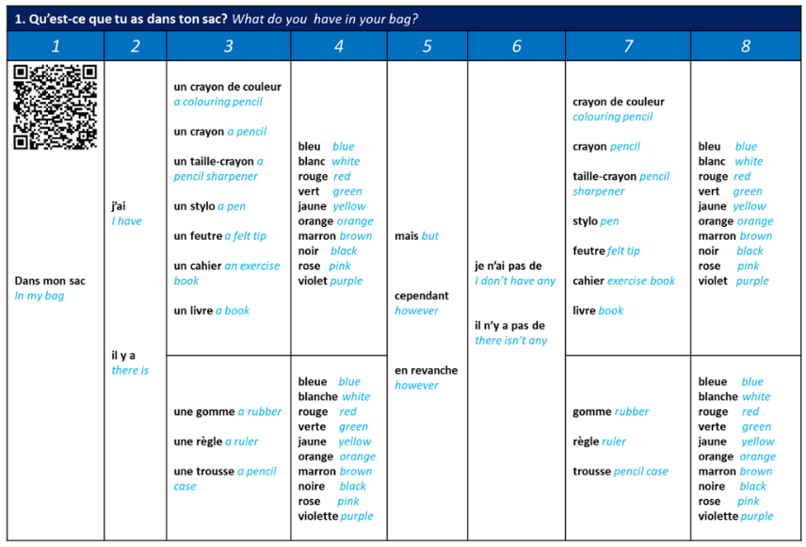

**Sentence Builder 2 – My lessons**

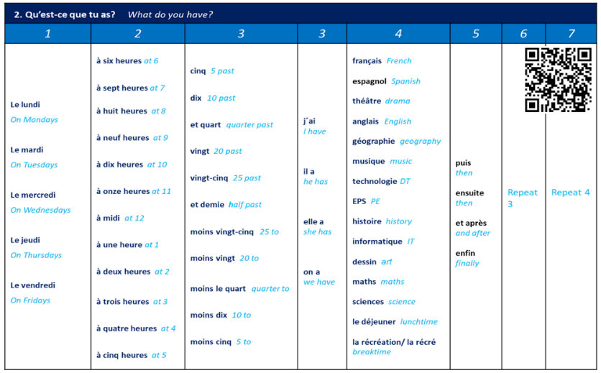

**Sentence Builder 3 – My opinions**

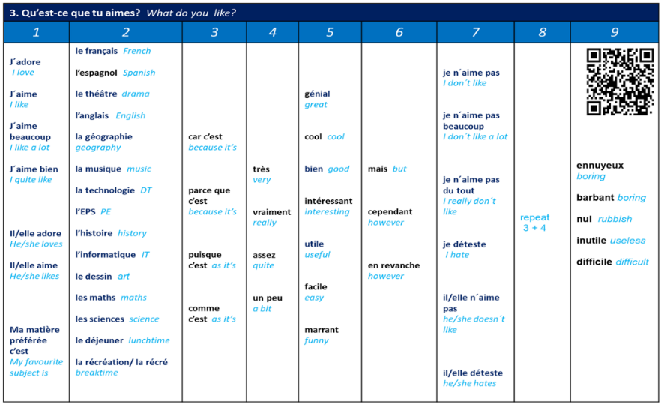

**Sentence Builder 4 – A day at school**

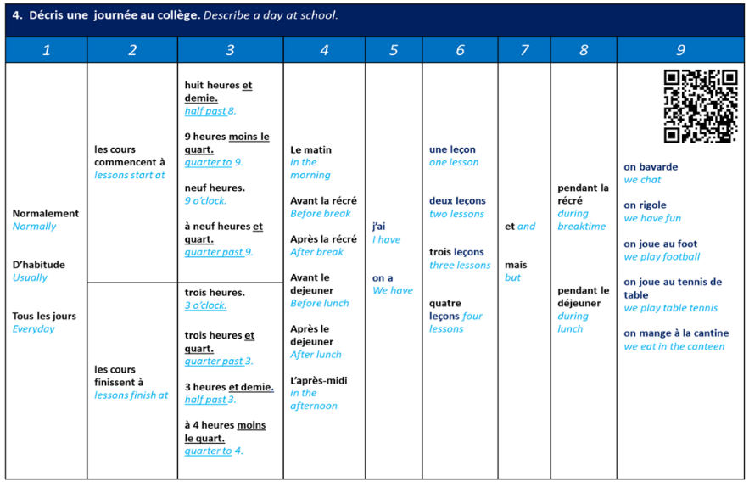

|  |  |
| --- | --- |
| cid:image001.png@01D65A8B.C226B940 | **Y7 GEOGRAPHY KNOWLEDGE ORGANISER – VICIOUS VOLCANOES** |

**LONG TERM PLAN**

|  |  |  |  |  |
| --- | --- | --- | --- | --- |
| **AUTUMN** | **⭢** | **SPRING** | **⭢** | **SUMMER** |
| Welcome to Geography  Brazil | Wonderous World Cities | Vicious Volcanoes |

|  |  |  |  |
| --- | --- | --- | --- |
|  | Name the four layers of the earth. | * Crust * Mantle * Outer core * Inner core |  |
|  | Name the two types of crust. | * Continental * Oceanic |  |
|  | What process moves tectonic plates? | Convection currents |  |
|  | Where are most volcanoes located? | Ring of fire |  |
|  | What drives convection currents? | Heat from the inner core |  |

|  |  |  |  |
| --- | --- | --- | --- |
|  | Describe what happens at a constructive plate boundary. | Two tectonic plates move apart |  |
|  | What term is used to describe two plates that are pushed together and the heavier oceanic crust gets pushed down? | Destructive plate boundary |  |
|  | Name the word where the heavier oceanic crust is pushed beneath the lighter continental crust. | Subducted |  |
|  | When did Eyjafjallajökull erupt? | 2010 |  |
|  | Name an impact of the Iceland volcano eruption. | * Ash * Flooding |  |

|  |  |  |  |
| --- | --- | --- | --- |
|  | Name two impacts of the Eyjafjallajökull ash cloud. | * Water sources poisoned. * People had to wear goggles and masks |  |
|  | How many earthquakes occurred since the 2020 Taal eruption? | 2,400 earthquakes |  |
|  | Name two impacts of the Taal eruption | * Houses destroyed * Roads damaged * Electricity and water cut off |  |
|  | What happens at hotspots? | Magma rises up through thin oceanic crust. |  |
|  | What is the difference between magma and lava? | * Magma is in the mantle. * Lava is on the earth’s surface. |  |

|  |  |  |  |  |
| --- | --- | --- | --- | --- |
|  | How much money did airlines lose each day after the Iceland eruption? | | £130 million |  |
|  | How many people were evacuated in preparation for the Icelandic volcano? | | 800 people |  |
|  | How many families did shelter box help after the 2020 Taal eruption? | | 2000 |  |
|  | What are two warning signs of a volcanic eruption? | | * Smoke * Earthquakes |  |
|  | Two benefits of living near a volcano? | | * Geothermal energy * Fertile soil |  |
| cid:image001.png@01D65A8B.C226B940 | | **Y7 GEOGRAPHY – WORLD MAP** | | | |

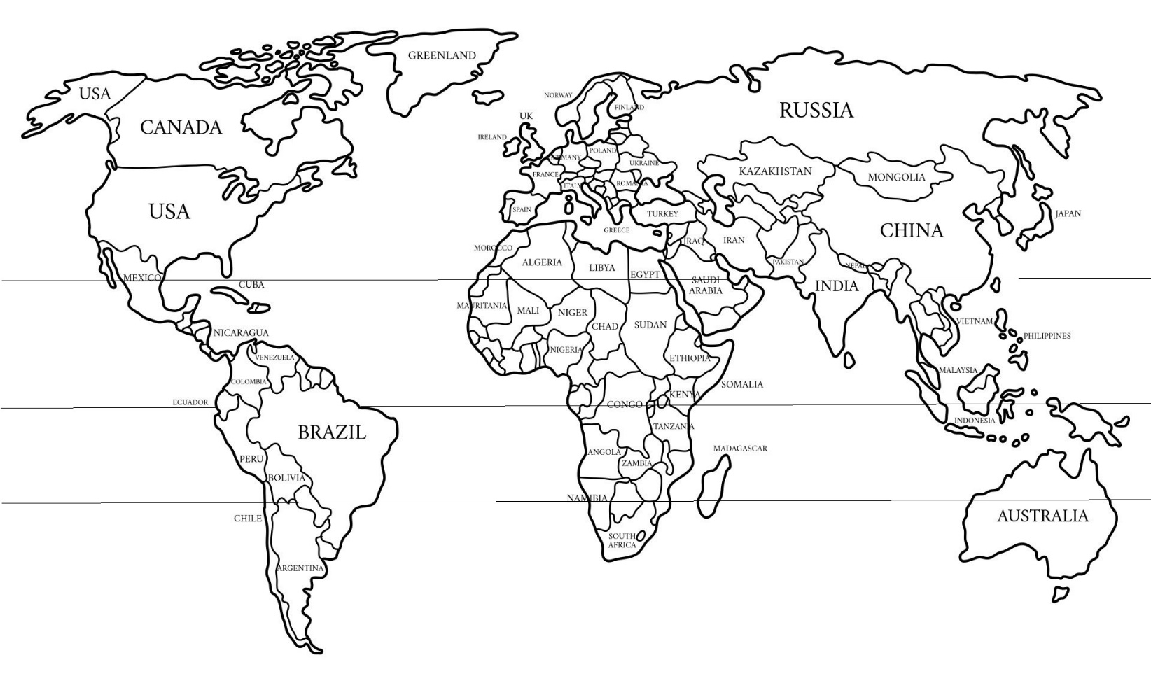

|  |  |
| --- | --- |
| cid:image001.png@01D65A8B.C226B940 | **Y7 HISTORY KNOWLEDGE ORGANISER – HOW HAVE HISTORIANS INTERPRETED THE CRUSADES?** |

**LONG TERM PLAN**

|  |  |
| --- | --- |
| **AUT1** | What can Dorset tell us about history? Where did England come from? |
| **AUT2** | How did power change in medieval England? |
| **SPR1** | What do sources tell us about disabled people in the middle ages? |
| **SPR2** | How did the Islamic golden age shape Europe? |
| **SUM1** | How have historians interpreted the crusades? |
| **SUM2** | How did the silk roads change the world? |

|  |  |  |  |
| --- | --- | --- | --- |
|  | What were the Crusades? | Religious wars between Christians and Muslims |  |
|  | How many Crusades were there during the Middle Ages? | Seven |  |
|  | Give two reasons why people wanted to go on Crusade. | * Religious devotion * Economic gain * Social status * Political power |  |
|  | Give one group of people who saw opportunity in going on Crusade. | * Knights * Peasants * Merchants |  |
|  | How did Muslim chroniclers describe the Crusaders? | Brutal invaders. |  |

|  |  |  |  |
| --- | --- | --- | --- |
|  | Which Christian empire viewed the Crusaders as both allies and threats? | The Byzantine Empire |  |
|  | What do Christian sources exaggerate? | Crusader heroism |  |
|  | How can historians confirm or challenge written records? | Archaeological evidence |  |
|  | Which female monarch played an active role in the Second Crusade? | Eleanor of Aquitaine |  |
|  | Why did medieval chroniclers often portray her negatively? | They were biased against powerful women |  |

|  |  |  |  |
| --- | --- | --- | --- |
|  | Who were the two legendary figures of the Third Crusade? | * Richard I (the Lionheart) of England. * Salah al-din (Saladin). |  |
|  | What event during the Third Crusade was demonstrated extreme violence? | The massacre at Acre |  |
|  | How did medieval European chroniclers view the Crusaders? | Holy soldiers |  |
|  | How did enlightenment thinkers view the Crusaders? | Barbaric and superstitious soldiers |  |
|  | How did Victorian historians view the Crusaders? | Noble warriors |  |

|  |  |
| --- | --- |
| cid:image001.png@01D65A8B.C226B940 | **Y7 HISTORY KNOWLEDGE ORGANISER –**  **HOW DID THE SILK ROADS CHANGE THE WORLD?** |

|  |  |  |  |
| --- | --- | --- | --- |
|  | What were the Silk Roads? | A network of trade routes connecting Asia, the Middle East and Europe. |  |
|  | When did the Silk Roads emerge? | 2nd century |  |
|  | When did the Silk Roads decline in importance? | 15th and 16th centuries |  |
|  | Give one example of a key group who used the Silk Roads. | * Chinese traders * Persian merchants * Arab caravans * Mongol rulers * European explorers |  |
|  | Give one historical focus that historians use to understand the Silk Roads. | * Economy * Culture * Conflict |  |

|  |  |  |  |
| --- | --- | --- | --- |
|  | Which three major religions spread along the Silk Roads? | * Buddhism * Islam * Christianity. |  |
|  | What new knowledge spread along the Silk Roads? | * Papermaking * Medicine * Mathematics |  |
|  | What disease spread along the Silk Roads during the 14th century? | Black Death (bubonic plague) |  |
|  | Who created the largest continuous empire in history? | The Mongols |  |
|  | Give one development they promoted in their empire. | * Trade * Cultural exchange * Infrastructure improvements |  |

|  |  |  |  |
| --- | --- | --- | --- |
|  | Which empire controlled access to the Silk Roads from Europe in the 16th century? | Ottoman Empire |  |
|  | What new type of trade routes did Europeans develop? | Maritime (sea routes) |  |
|  | Which continent did Europeans begin travelling to by the 16th century? | North America |  |
|  | How do we see the impact of the Silk Roads today? | Modern globalisation |  |
|  | In the 21st century, which country has a project called the ‘Belt and Road Initiative’ which is inspired by the Silk Roads? | China |  |

|  |  |
| --- | --- |
|  | **Y7 MATHS KNOWLEDGE ORGANISER** |

**LONG TERM PLAN**

|  |  |  |  |  |  |  |  |  |  |  |
| --- | --- | --- | --- | --- | --- | --- | --- | --- | --- | --- |
| **AUT1** | **⭢** | **AUT2** | **⭢** | **SPR1** | **⭢** | **SPR2** | **⭢** | **SUM1** | **⭢** | **SUM2** |
| Number 1 | Number 2  Algebra | Fractions | Ratio and Proportion | Geometry | Perimeter, Area and Volume |

In Maths, all lessons begin with a Knowledge Quiz. Lessons held earlier in the week provide opportunities to practice the skills and receive feedback from your teacher. Always mark your practice quizzes thoroughly and glue them into your self-quizzing exercise book.

|  |  |
| --- | --- |
| Times Table Grid to 12x12 | Math Number Lines | Common-Core Resources For Kids |

|  |  |
| --- | --- |
|  | **Y7 MATHS KNOWLEDGE ORGANISER – GEOMETRY** |

|  |  |  |  |
| --- | --- | --- | --- |
|  | What word describes a line connecting two points? | Line segment |  |
|  | What word describes a point halfway between the two points? | Midpoint |  |
|  | What word describes two lines that never intercept (cross) each other? These are indicated using arrows. | Parallel |  |
|  | What word describes two lines that intercept or cross at right angles | Perpendicular |  |
|  | What word describes two identical objects of the same size and same shape? | Congruent |  |

|  |  |  |  |
| --- | --- | --- | --- |
|  | What word describes a 2D object with any number of straight sides? | Polygon |  |
|  | What type of polygon has equal length sides and equal angles? | Regular polygon |  |
|  | What type of polygon does not have equal length sides and equal angles? | Irregular polygon |  |
|  | What type of triangle contains one 90⁰ angle? | Right angled-triangle |  |
|  | What type of triangle has three equal length sides and three equal angles (all 60⁰)? | Equilateral triangle |  |

|  |  |  |  |
| --- | --- | --- | --- |
|  | What type of triangle has two equal length sides and two equal angles? | Isosceles triangle |  |
|  | What type of triangle has no equal length sides and no equal angles? | Scalene triangle |  |
|  | What is the name of any four sided shape? | Quadrilateral |  |
|  | What type of quadrilateral has both pairs of opposite sides parallel? | Parallelogram |  |
|  | What type of parallelogram has all sides equal? | Rhombus |  |

|  |  |  |  |
| --- | --- | --- | --- |
|  | What type of parallelogram has four right angles? | Rectangle |  |
|  | What type of parallelogram has all sides equal and four right angles? | Square |  |
|  | What type of quadrilateral has one pair of parallel sides? | Trapezium |  |
|  | What type of quadrilateral has two pairs of equal adjacent sides but unequal opposite sides? | Kite |  |
|  | What word describes the 2D shape that makes up one surface of a 3D object? | Face |  |

|  |  |  |  |
| --- | --- | --- | --- |
|  | What word describes where two faces meet on a 3D object? | Edge |  |
|  | What word describes the point or corner of a geometric shape? | Vertex |  |
|  | What type of 3D object has flat sides and each of its ends are the same size and shape? | Prism |  |
|  | What type of prism has six square faces? | Cube |  |
|  | What type of prism has all rectangular faces? | Cuboid |  |

|  |  |  |  |
| --- | --- | --- | --- |
|  | What type of prism has a circular cross section? | Cylinder |  |
|  | What type of prism has a triangular cross section? | Triangular prism |  |
|  | What type of 3D object has four triangular faces and a square base? | Square based pyramid |  |
|  | What type of 3D object has four triangular faces? | Tetrahedron |  |
|  | What type of 3D object has one curved face, with every point on its surface equidistant from its centre? | Sphere |  |

|  |  |  |  |
| --- | --- | --- | --- |
|  | What word describes how a 3D object can be represented in 2D form? | Net |  |
|  | What word describes the bird eye view of a 3D object? | Plan |  |
|  | What word describes the side view of a 3D object? | Elevation |  |
|  | What word describes a measure of turn? | Angle |  |
|  | What unit are angles measured in? | Degrees |  |

|  |  |  |  |
| --- | --- | --- | --- |
|  | How many degrees are there is a full turn? | 360⁰ |  |
|  | What is the sum of angles around a point? | 360⁰ |  |
|  | How many degrees are there is a half turn? | 180⁰ |  |
|  | What is the sum of adjacent angles on a straight line? | 180⁰ |  |
|  | What type of angle is less than 90⁰? | Acute |  |

|  |  |  |  |
| --- | --- | --- | --- |
|  | What type of angle is more than 90⁰ but less than 180⁰? | Obtuse |  |
|  | What type of angle is more than 180⁰ but less than 360⁰? | Reflex |  |
|  | What is the sum of the angles in a triangle? | 180⁰ |  |
|  | What is the sum of the angles in a quadrilateral? | 360⁰ |  |
|  | What type of angle describes opposite angles where two lines intersect? | Vertically opposite |  |

|  |  |  |  |
| --- | --- | --- | --- |
|  | What word describes a line crossing two or more parallel lines? | Transversal |  |
|  | What type of equal angles lie on opposite sides of parallel lines and the opposite side of a transversal? | Alternate |  |
|  | What type of equal angles lie on the same side of parallel lines and the same side of a transversal? | Corresponding |  |
|  | What type of angle, which sums to 180⁰, lie on opposite sides of parallel lines and the same side of a transversal? | Allied |  |
|  | What is the name of the angle between an extended side of a polygon and its adjacent side? | Exterior angle |  |

|  |  |  |  |
| --- | --- | --- | --- |
|  | What is the name of the angle between two adjacent sides of a polygon? | Interior angle |  |
|  | What is the sum of exterior angles of any polygon? | 360⁰ |  |
|  | What is the sum of adjacent interior and exterior angles? | 180⁰ |  |
|  | What word describes an angle measured from North, measured clockwise and written using three digits? | Bearing |  |
|  | What type of drawing reduces all dimensions of an object by the same proportion? | A scale drawing |  |

|  |  |
| --- | --- |
|  | **Y7 MATHS KNOWLEDGE ORGANISER – PERIMETER, AREA, VOLUME** |

|  |  |  |  |
| --- | --- | --- | --- |
|  | What term describes the distance around the outside of a 2D shape? | Perimeter |  |
|  | What term describes the space inside a 2D shape? | Area |  |
|  | How do you calculate the area of a rectangle? | A = base x perpendicular height |  |
|  | How do you calculate the area of a parallelogram? | A = base x perpendicular height |  |
|  | How do you calculate the area of a triangle? | A = ½ x base x perpendicular height |  |
|  | How do you calculate the area of a trapezium? |  |  |

|  |  |  |  |
| --- | --- | --- | --- |
|  | What term describes a shape made up of more than one common shape? | Composite shape |  |
|  | What term describes the space inside a 3D object? | Volume |  |
|  | How do you calculate the volume of a prism? | V = Area of cross-section x length |  |
|  | How do you calculate the volume of a cuboid? | V = length x width x height |  |
|  | What term describes the total area of each face of a 3D object? | Surface area |  |

|  |  |
| --- | --- |
| cid:image001.png@01D65A8B.C226B940 | **Y7 MUSIC KNOWLEDGE ORGANISER –**  **UNIT 7.3: COMPOSITION FOUNDATIONS** |

**LONG TERM PLAN**

|  |  |  |  |  |
| --- | --- | --- | --- | --- |
| **AUTUMN** | **⭢** | **SPRING** | **⭢** | **SUMMER** |
| Wake Me Up Performance | Baroque Music | Composition Foundations |

|  |  |  |  |
| --- | --- | --- | --- |
|  | What is a minor chord? | A chord with three or more notes that sounds sad. |  |
|  | Which three notes are highlighted here and what is the name of the chord? 1E46A9BF | A C E = Am (A minor) |  |
|  | What is the advantage of making an audio recording rather than a MIDI recording on a Digital Audio Workstation – e.g. Soundtrap? | Some things, like singing, are very hard or impossible to recreate using MIDI |  |
|  | What is the advantage of recording on a MIDI track on a DAW (Digital Audio Workstation)? | You can edit any or all of the notes very easily to correct them or improve them. |  |
|  | Why is it important to listen to a metronome whilst recording your parts? | It will help you to play in time with the beat which makes the music sound much better. |  |

|  |  |  |  |  |
| --- | --- | --- | --- | --- |
|  | What is dissonance? | Dissonance is when you choose notes that clash together and sound unpleasant rather than creating a nice harmony. | |  |
|  | Name three parts of the music that are classed as a harmony: | Chords Bassline  Pedal-note | |  |
|  | Name four string instruments: | Violin  Viola  Cello  Double bass | (will also accept any other valid string instrument answer) |  |
|  | Name four brass instruments: | Trumpet  Trombone  French Horn  Tuba | (will also accept any other valid brass instrument answer) |  |
|  | Name four woodwind instruments: | Flute  Clarinet  Oboe  Saxophone | (will also accept any other valid woodwind instrument answer) |  |
|  | Name four percussion instruments: | Snare drum  Crash cymbal  Bass drum  Timpani | (will also accept any other valid percussion instrument answer) |  |

|  |  |
| --- | --- |
| cid:image001.png@01D65A8B.C226B940 | **Y7 PRE KNOWLEDGE ORGANISER – UNIT 4: CHRISTIANITY** |

**LONG TERM PLAN**

|  |  |  |  |  |
| --- | --- | --- | --- | --- |
| **AUTUMN** | **⭢** | **SPRING** | **⭢** | **SUMMER** |
| Who am I?  The influencers | Judaism | Christianity |

|  |  |  |  |
| --- | --- | --- | --- |
|  | What word describes someone who has faith in something and accepts it is true? | **Belief** |  |
|  | What word describes someone who believes in God? | **Theist** |  |
|  | What word describes a person who does not believe in God? | **Atheist** |  |
|  | What word describes someone who is unsure if God exists or not? | **Agnostic** |  |
|  | How many followers does Christianity have in the world? | 2 billion |  |

|  |  |  |  |
| --- | --- | --- | --- |
|  | Who started **Christianity**? | Followers of Jesus |  |
|  | How many years ago did Christianity start? | 2000 |  |
|  | Is Christianity an eastern or western faith? | Western |  |
|  | What country did Christianity start in? | Israel |  |
|  | What word describes one God? | **Monotheism** |  |

|  |  |  |  |
| --- | --- | --- | --- |
|  | What word describes God being all powerful? | **Omnipotent** |  |
|  | What word describes God being all loving? | **Omnibenevolent** |  |
|  | Who are these beliefs about:   * Creator of the world, * Came down to earth in human form as Jesus to die for human sin so people can get to heaven? | God |  |
|  | What word for God has three parts: Father, Son and Holy Spirit? | **Trinity** |  |
|  | Where do Christian’s worship? | **Church** |  |

|  |  |  |  |
| --- | --- | --- | --- |
|  | What do you call a religious leader for Christianity? | **Priest** or vicar |  |
|  | State the name of the Christian holy book? | **Bible** |  |
|  | What is the word for many books? | Biblica |  |
|  | Why is the Bible important for Christians? | They believe it is the word and revelation of God |  |
|  | How many main parts is the Bible split into? | Two |  |

|  |  |  |  |
| --- | --- | --- | --- |
|  | What is the name for the Jewish part of the Bible? | **Old testament** |  |
|  | What is the name for Jesus’ teachings and the early Christian stories in the Bible? | **New testament** |  |
|  | What is the word which means the good news of Jesus? | **Gospel** |  |
|  | How many gospels are there? | Four |  |
|  | Who was Jesus’s father? | **God** or **Joseph** |  |

|  |  |  |  |
| --- | --- | --- | --- |
|  | What religion was Jesus? | **Jewish** |  |
|  | Why is Jesus so important? | Christians believe Jesus is God who died to atone for human sin so that humans can have eternal life. |  |
|  | What does **incarnation** mean? | God in human form (Jesus) |  |
|  | What does **salvation** mean? | To be saved |  |
|  | Who do Christians believe saved them? | Jesus |  |

|  |  |  |  |
| --- | --- | --- | --- |
|  | What word means to come back to life? | **Resurrect** |  |
|  | What is an event that goes against the laws of nature and is caused by God? | **Miracle** |  |
|  | What are three examples of miracles? | * Feeding of the 5000. * Curing a man who could not walk. * Resurrecting from the dead. |  |
|  | What does **creed**/credo mean? | ‘I believe’ |  |
|  | Where can you find the key statements of the Christian belief? | **Apostles’ creed** |  |

|  |  |  |  |
| --- | --- | --- | --- |
|  | What does the word **disciple** mean? | Follower of God |  |
|  | What does **Philos**/**philia** **love** mean? | Friendship love |  |
|  | What does **storge love** mean? | Sentimental love |  |
|  | What does **eros love** mean? | Love between couples |  |
|  | What does **agape love** mean? | Unconditional love |  |

|  |  |  |  |
| --- | --- | --- | --- |
|  | What does the story of the **good Samaritan** teach? | Love |  |
|  | What is the **golden rule**? | To ‘treat others as you want to be treated’. |  |
|  | What does **beatitudes** mean? | Happy or blessed |  |
|  | What are the four weeks called waiting for Jesus to be born? | **Advent** |  |
|  | Give an example of a Christian festival. | * Christmas * Easter |  |

|  |  |
| --- | --- |
| cid:image001.png@01D65A8B.C226B940 | **Y7 SCIENCE KNOWLEDGE ORGANISER** |

**LONG TERM PLAN**

|  |  |
| --- | --- |
| **AUTUMN** | Safety, Weights and Measures  Chemistry 1 – 3: Atoms, Acids and Alkalis  Physics 1 – 3: Energy and Electricity |
| **SPRING** | Biology 1 – 3: Living Things and The Environment  Physics 4 – 6: Forces, Motion and Magnets |
| **SUMMER** | Biology 4 – 6: Classification, Photosynthesis and Digestion  Chemistry 4 – 6: Mixtures Compounds and Reactions |

|  |  |
| --- | --- |
| cid:image001.png@01D65A8B.C226B940 | **Y7 SCIENCE KNOWLEDGE ORGANISER –**  **BIOLOGY 4 – 6: CLASSIFICATION, PHOTOSYNTHESIS AND DIGESTION** |

|  |  |  |  |
| --- | --- | --- | --- |
|  | What term is used for the grouping of organisms based on their similarities? | Classification |  |
|  | What term do we used for the differences between organisms? | Variation |  |
|  | What do we call an animal that has a backbone? | Vertebrate |  |
|  | What type of variation that can NOT be divided into distinct groups? | Continuous |  |
|  | Blood groups are an example of what type of variation? | Discontinuous |  |

|  |  |  |  |
| --- | --- | --- | --- |
|  | What term describes the passing of characteristics from parents to offspring? | Inheritance |  |
|  | What controls the features we inherit from our parents? | Genes |  |
|  | What term is used for variation NOT caused by inheritance? | Environmental |  |
|  | What is the term we use for organisms that use light energy to produce glucose and are at the start of the food chain? | Producer |  |
|  | What is the term we use for the mass of living tissues that an organism is made up of? | Biomass |  |

|  |  |  |  |
| --- | --- | --- | --- |
|  | What 2 chemical reactants do plants take in for the process of photosynthesis? | * Carbon dioxide * Water |  |
|  | What are the 2 chemicals made during photosynthesis? | * Glucose * Oxygen |  |
|  | What type of energy is needed for photosynthesis? | Light |  |
|  | What can glucose be stored as in plants? | Starch |  |
|  | What is the test for starch in leaves? | Iodine turns blue/black |  |

|  |  |  |  |
| --- | --- | --- | --- |
|  | What is the name for the holes in leaves that the gases can pass through? | Stomata |  |
|  | What is the name of the cells that control the size of the stomata? | Guard Cells |  |
|  | What food type is the main source of energy? | Carbohydrates |  |
|  | What food type is needed for growth and repair? | Protein |  |
|  | What food type is a STORE of energy? | Fats |  |

|  |  |  |  |
| --- | --- | --- | --- |
|  | Name the chemical used to test for Glucose | Benedict’s Solution |  |
|  | Name the chemical used to test for Protein | Biuret reagent |  |
|  | What do we call the chemicals that break down food? | Enzymes |  |
|  | Enzymes speed up chemical reactions and are called _______? | Biological Catalysts |  |
|  | What are the finger-like projections in the small intestine called? | Villi |  |

|  |  |
| --- | --- |
| cid:image001.png@01D65A8B.C226B940 | **Y7 SCIENCE KNOWLEDGE ORGANISER –**  **CHEMISTRY 4 – 6: MIXTURES COMPOUNDS AND REACTIONS** |

|  |  |  |  |
| --- | --- | --- | --- |
|  | What do we call different substances that are not chemically joined? | A mixture |  |
|  | What do we call a substance containing only one type of chemical? | Pure |  |
|  | What do we call the liquid that a solid can dissolve in? | A solvent |  |
|  | What do we call the solid that dissolves in a liquid? | The solute |  |
|  | What do we call a solid that will dissolve? | Soluble |  |

|  |  |  |  |
| --- | --- | --- | --- |
|  | What do we call a solid that will not dissolve? | Insoluble |  |
|  | What do we call a mixture of solvent and solute? | A solution |  |
|  | What do we call a solution that cannot hold any more solute? | Saturated |  |
|  | How do we separate an insoluble solid from a liquid? | Filtration |  |
|  | How do we separate and identify a mixture of soluble substances?  E.g. inks or dyes | Chromatography |  |

|  |  |  |  |
| --- | --- | --- | --- |
|  | What do we call the chemicals that react together? | Reactants |  |
|  | What do we call the new substances formed in a chemical reaction? | Products |  |
|  | What is a pure substance that consists of only one type of atom? | Element |  |
|  | What contains two or more different elements, chemically bonded in a fixed ratio? | Compound |  |
|  | What do we call a particle formed from 2 or more non-metals bonded together? | Molecule |  |

|  |  |  |  |
| --- | --- | --- | --- |
|  | What two substances are produced when a hydrocarbon fuel burns completely? | * Carbon dioxide * Water |  |
|  | What gas turns limewater cloudy? | Carbon dioxide |  |
|  | What gas burns with a squeaky pop? | Hydrogen |  |
|  | What gas will relight a glowing splint? | Oxygen |  |
|  | What gas bleaches damp litmus paper? | Chlorine |  |

|  |  |  |  |  |
| --- | --- | --- | --- | --- |
|  | What contains two or more different elements, chemically bonded in a fixed ratio? | | Compound |  |
|  | What is the ending of a compound that only contains two elements? | | -ide |  |
|  | What is the ending of a compound that contains three elements, including oxygen | | -ate |  |
|  | What do we call a reaction where heat is used to break a substance down? | | Thermal decomposition |  |
| cid:image001.png@01D65A8B.C226B940 | | | **Y7 SCIENCE KNOWLEDGE ORGANISER –**  **PHYSICS 4 – 6: FORCES, MOTION AND MAGNETS** | | | |

|  |  |  |
| --- | --- | --- |
|  | What do you need in order to make something change?  E.g. shape, direction, speed | A force |
|  | What is the name of the force that always pulls you downwards? | Gravity |
|  | What name is given to materials that can deform when a force is applied but the return to their original shape? | Elastic |
|  | What name is given to materials that can deform when a force is applied but cannot return to their original shape? | Plastic |
|  | What is the name of the variable in an investigation that I change deliberately? | Independent variable |

|  |  |  |
| --- | --- | --- |
|  | What is the name of the variable in an investigation that DOES change (but we are not in control of it)? | Dependent variable |
|  | What do we call variables in an investigation that CANNOT change? | Control Variables |
|  | What do you call it when the forces on an object all cancel each other out? | Balanced |
|  | What is the force that always opposes motion? | Friction |
|  | Where is the strongest magnetic force found on a magnet? | At the poles |

|  |  |  |
| --- | --- | --- |
|  | What happens when similar poles on a magnet face each other? | They repel |
|  | What happens when opposite poles on a magnet face each other? | They attract |
|  | What is the name of the region around a magnet that it can affect? | The magnetic field |
|  | Name 2 ways to increase the strength of an electromagnet | * Use and iron core * Increase the supply voltage |
|  | When unbalanced forces act on a car what 3 things can happen? | * Change speed * Change direction * Change shape |

|  |  |  |
| --- | --- | --- |
|  | How do you calculate the average speed of an object? | $$Speed=\frac{Distance travelled}{Time taken}$$ |
|  | What units do we measure speed in (for science)? | Meters per second (m/s) |
|  | What scientific term is used to describe how much of something there is? | Mass |
|  | What scientific term is used to describe how much gravity pulls down on an object? | Weight |
|  | How do you calculate the weight of an object? | Weight = mass x gravitational field strength |

|  |  |
| --- | --- |
| cid:image001.png@01D65A8B.C226B940 | **Y7 SPANISH KNOWLEDGE ORGANISER – MY HOME** |

**LONG TERM PLAN**

|  |  |  |  |  |
| --- | --- | --- | --- | --- |
| **AUTUMN** | **⭢** | **SPRING** | **⭢** | **SUMMER** |
| All About Me | My Free Time | My Home |

**Sentence Builder 1 – Where I live**

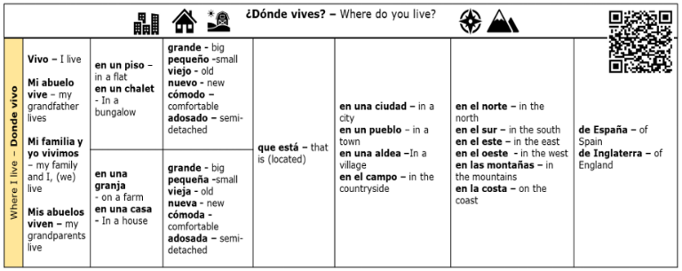

**Sentence Builder 2 – My house**

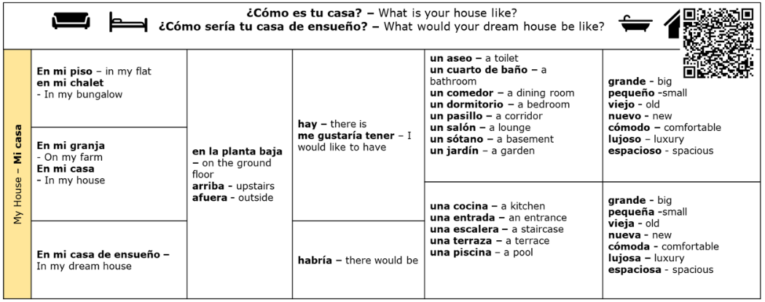

**Sentence Builder 3 – My bedroom**

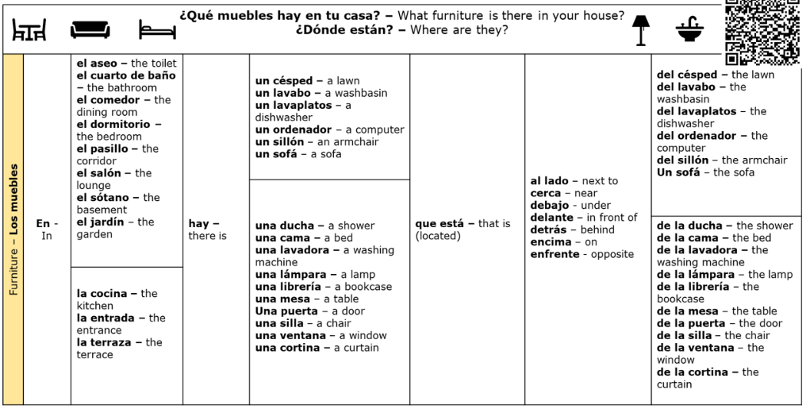

**Sentence Builder 4 – Putting it all together**

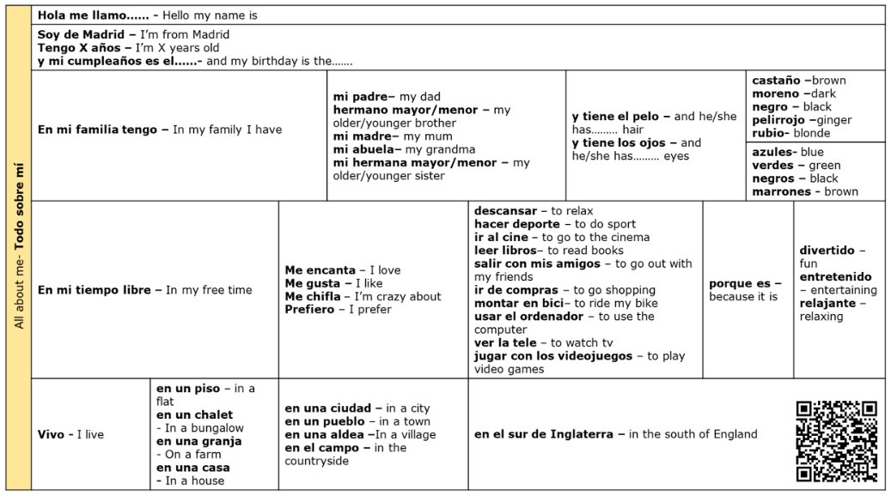

**LEARNING TO USE THE LIBRARY**

Fiction (story books) are arranged by *genre* – that’s the *style* of book.

1. Can you write down three different genres, and an example of a book from each?

|  |  |
| --- | --- |
| **Genre** | **Book** |
|  |  |
|  |  |
|  |  |

1. What do you notice about how the books are arranged within each genre?

_____________________________________________________________________

1. How is this helpful?

_____________________________________________________________________

1. How many books can you borrow? And for how long?

_____________________________________________________________________

1. What will you do if you want to keep your books for longer?

_____________________________________________________________________

You can use the **Web App** to find all sorts of information about the library and to look up books.

Click on the **Windows icon** – then **Library** – then **The Purbeck School AccessIt Library**.

(Or, open Google Chrome and type in [**https://uk.accessit.online/thp04/**](https://uk.accessit.online/thp04/))

Click on ‘Guest’ in the top right corner, then the blue box ‘Log in with school details’.

Click in the search box and type in ‘House with chicken legs’.

Who is the author? ________________________________________________________

How many copies are available? ________ What genre is it? _____________________

Try another search – choose your own book to look up.

What is the book? _________________________________________________________

Do we have it in the library? _________________________________________________

If you have time, you can look at some of the other information on the home screen.

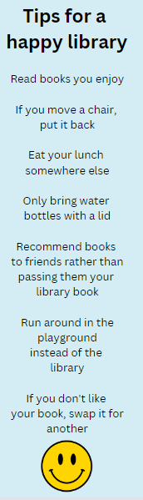

**How to use the Purbeck School Library**

* + - * + You may borrow up to 3 books at a time for 2 weeks.
        + The date a book is due back is stamped in the front of the book
        + If you need a book for longer, just come to the library to renew it.
        + You can come to the library before school and at any break time.
        + Fiction books are arranged by genre (or type of book) – have a

look at the map below to see how to find the book you want.

**Using the Library WebApp**



Go to <https://uk.accessit.online/thp04/> or scan the QR code to find the

library WebApp. You can search for books, see what you have on loan,

and find book recommendations under Quicklists and Dashboards.

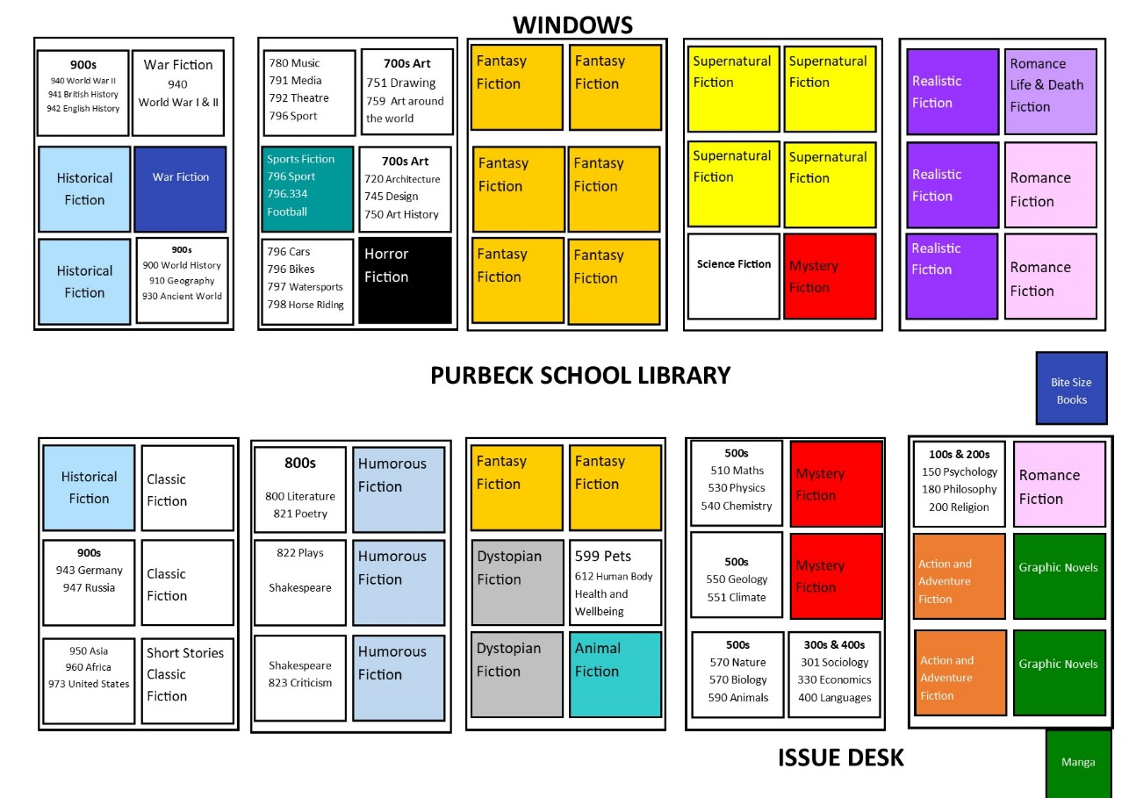

**SCHOOL MAP**

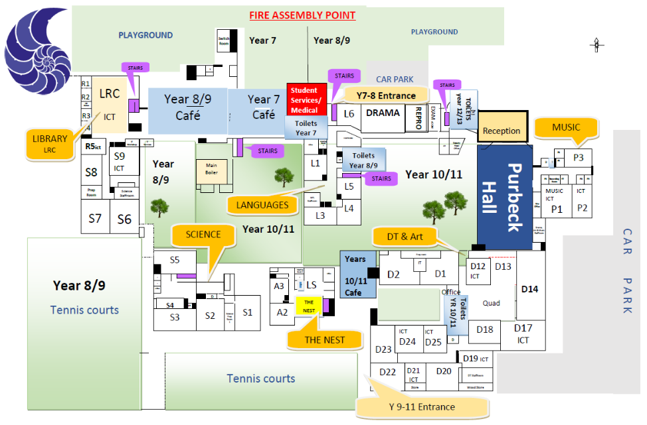

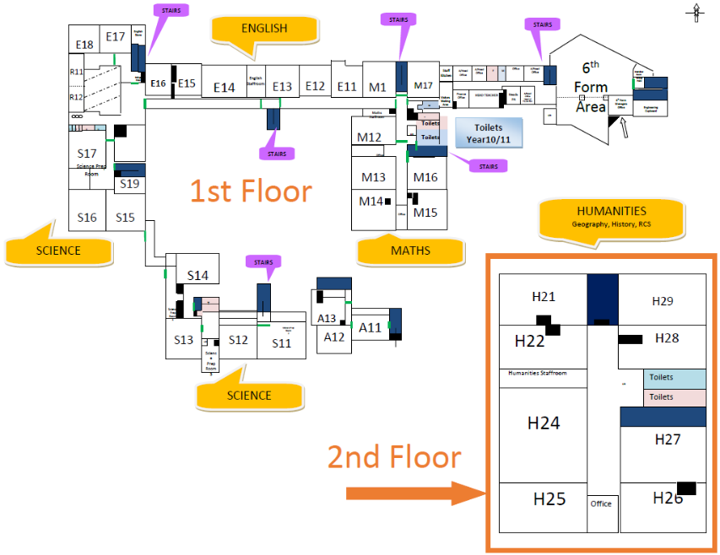

|  |  |
| --- | --- |
| cid:image001.png@01D65A8B.C226B940 | **PURBECK AND PROUD** |

|  |  |  |  |  |  |  |  |  |  |  |
| --- | --- | --- | --- | --- | --- | --- | --- | --- | --- | --- |
| **Moving Around School** |  | **Break Time** |  | **Kindness** |  | **Presentation** |  | **In lessons** |  | **Behaviour outside of School** |
| **We move with purpose**   * *We keep to the left.* * *We do not run inside.*   **We are proud of our site**   * *We pick up litter, coats and resources on the floor, if left untidy.* * *We carry our kindness cards at all times. We wear uniform with pride.*   **We are polite**   * *We do not shout.* * *We are kind to all.* * *We open doors for others.* * *We knock and wait for permission to enter a room.* |  | **We are safe**   * *We walk to our areas.* * *We do not hurt others.*   **We are proud**   * We include others. * We are kind to all. * We collect rubbish.   **We are patient**   * *We line up calmly for the canteen.*   **We are prompt**   * *We pack up when instructed.* * *We move with purpose to our lessons.* |  | **We are polite**   * *We say ‘please and thank you’.* * *We say ‘Good morning and Good afternoon’*   **We are professional**   * *We offer to let others through a door way.* * *We give eye contact.* |  | **We are proud**   * *We wear uniform correctly in line with the uniform policy.* * *We remove outdoor clothing (coat, hats, gloves, scarves etc.) once inside the classroom.*   **We take pride in our books**   * *Titles and dates are underlined.* * *Work should be completed.* * *Worksheets should be glued in.* * *No graffiti.* * *Any crossed out work should be with a single line.* |  | **We are punctual**   * *We line up outside the classroom, with the right equipment, until we are greeted by a member of staff who will welcome us into the room.*   **We are engaged**   * *We ask and answer questions.* * *We listen to others.* * *We sit up, face the front and track the speaker.*   **We do not disrupt others**   * *We follow instructions at all times.* * *We apologise following a reset. ​*   **We leave lessons with pride**   * *We address uniform.* * *We place chairs under the table.* * *We leave a row one at a time.* |  | **We are safe**   * *We stay safe online and use technology sensibly and safely.* * *We are mindful of pedestrians, cyclists and cars.* * *We are safe on the bus.* * *We know who to go to for help and support.*   **We take pride**   * *We understand we represent the school when wearing our uniform.* * *We behave responsibly and respectfully.* * *We are considerate of others.*   **We are polite**   * *We say thank you to the bus driver and others.* * *We are kind to all on the way home.* |