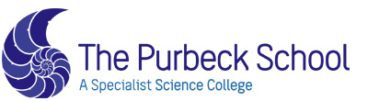
OUR KEY ADULTS ARE:
Mark Lawson
Rachel Stevens
Operation Encompass Safeguarding Statement
Our school is part of Operation Encompass. This is a police and education early intervention safeguarding partnership which supports children and young people who experience Domestic Abuse.
Operation Encompass means that the police will share information about Domestic Abuse incidents with our school PRIOR to the start of the next school day when they have been called to a domestic incident
Once a Key Adult (Designated Safeguarding Lead) has attended at an Operation Encompass briefing they will the principles of Operation Encompass to all Safeguarding Lead’s in school.
Our parents are fully aware that we are an Operation Encompass school.
The Operation Encompass information is stored in line with all other confidential safeguarding and child protection information.
The Key Adult has also led training for all school staff and Governors about Operation Encompass, the prevalence of Domestic Abuse and the impact of this abuse on children. We have also discussed how we can support our children following the Operation Encompass notification.
We are aware that we must do nothing that puts the child/ren or the non-abusing adult at risk.
The Safeguarding Governor will report on Operation Encompass in the termly report to Governors. All information is anonymised for these reports.
The Key Adult has used the Operation Encompass Toolkit to ensure that all appropriate actions have been taken by the school.

